**YOGA POSE ESTIMATION AND FEEDBACK**

**Abstract:**

**Project goal:**

Yoga pose estimation is the detection and recognition of specific yoga poses performed by a person using computer vision techniques. Practising yoga can improve flexibility, strength, and overall physical fitness, while also promoting relaxation and reducing stress levels. The goal of the project is to help common people practice yoga poses with proper posture and body alignment on their own, in order to prevent serious injuries that can be caused by practising yoga asanas with incorrect body alignment in the long run. Getting feedback on the correctness of the yoga posture can have huge benefits in learning and practising the yoga asanas.

**Technology:**

The project is an implementation of OpenCV and Mediapipe libraries. OpenCV is an open-source computer vision library that provides a wide range of functions for image and video processing. MediaPipe is a cross-platform, high-fidelity body pose tracking solution framework, that is used for building multi-modal applied machine learning pipelines. The project utilises MediaPipe to obtain the 33 major landmark coordinates of the human body. MediaPipe utilizes BlazePose[1] topology, a superset of COCO[2], BlazeFace[3], and BlazePalm[4] topology. These landmark coordinates form the basis for the pose estimation. The appropriate angles formed by landmarks while performing the asana precisely are compared to the person’s live feed of performingthe asana. The project then provides voice feedback so that the person can make alterations to the pose and avoid misalignment of the body so that the yoga asana can be performed efficiently without developing aches while attaining the numerous benefits of practising yoga.

**Snapshots:**

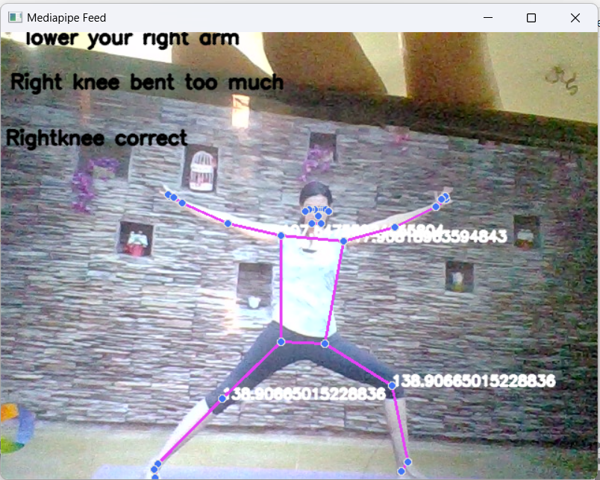

Feedback to rectify incorrect posture.

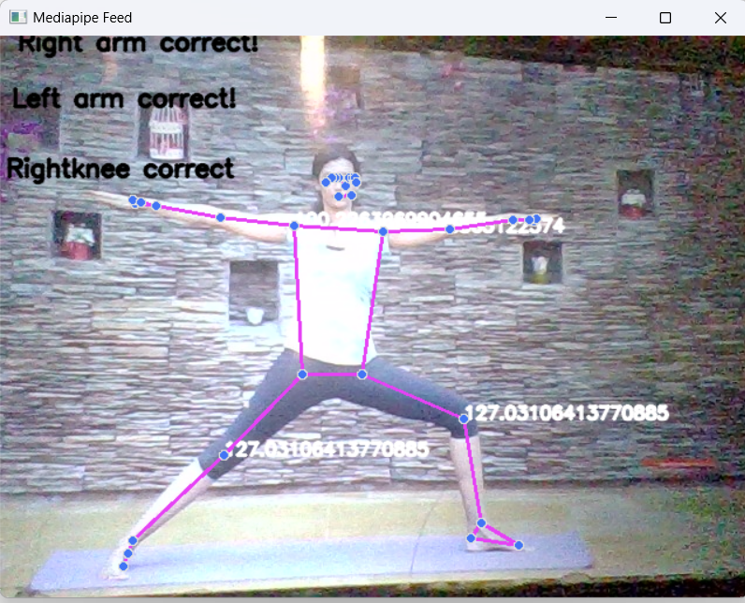

Feedback indicating that the posture is done efficiently.